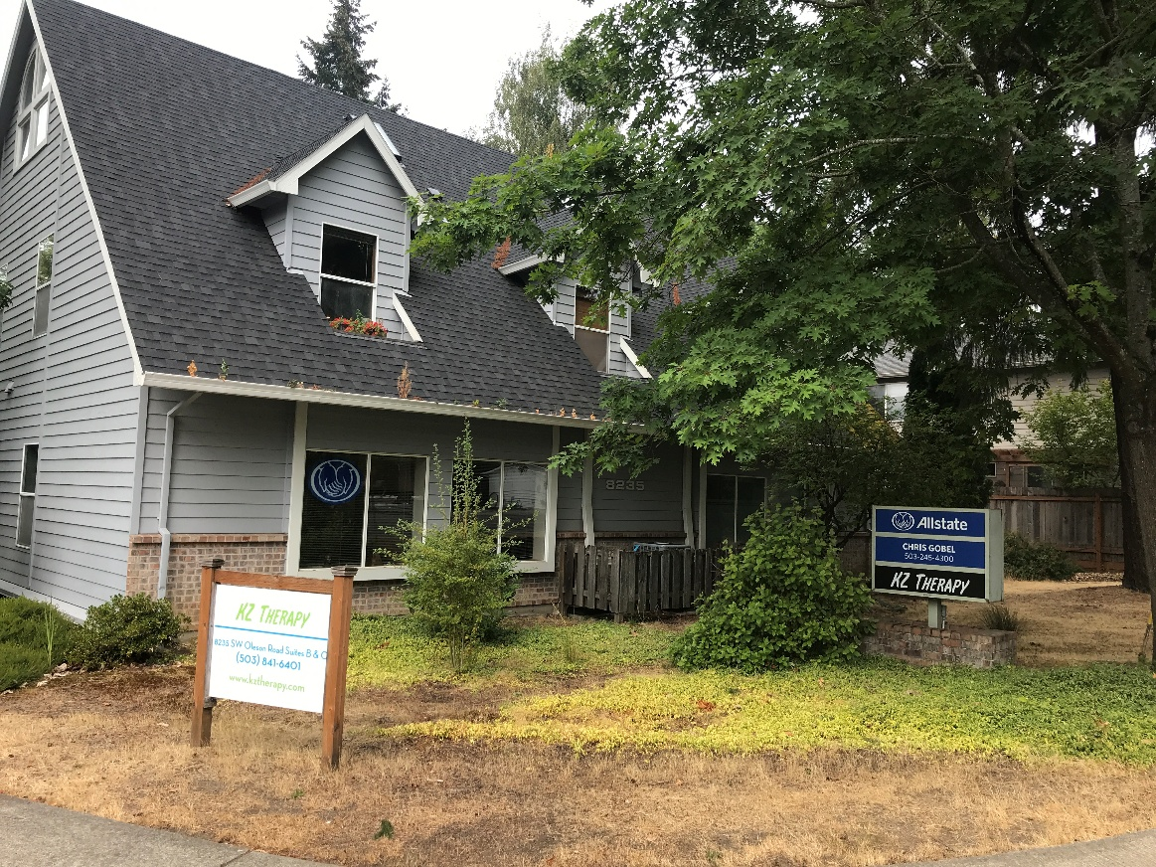

**SW PROFESSIONAL OFFICE BUILDING**

8235 SW OLESON ROAD, PORTLAND, OR

* Three office suites. Two story building plus garage. Suites A and B on main floor.
* Excellent parking (10 spaces behind building) and good signage on major SW arterial.
* 2nd floor suite C 1,500 sf: skylights, vaulted ceiling, kitchen, bath w shower.
* Main Floor: Suites A and B. Both approx. 750 sf each. One with kitchen/bath w shower
* Quiet, leafy setting located just N of Washington Square. Zoning allows residential use
* Currently leased short term to counseling group. Please do not disturb occupants.
* Call office for terms and inspection arrangements.

**For Sale**

**DEVLIN PROPERTIES CONTACT: MIKE DEVLIN**

10425 SW 55TH AVENUE phone: 503-246-4045/ 503-901-5407

PORTLAND, OR 97219 mdevprop@hotmail.com

* Approx. 3,000 sf plus garage + Loft

* Garden Home Wash. Co. location
* PRICE: $695,000. Cash/ poss. Terms
* Owner/User opp. Or extend current tenant lease.