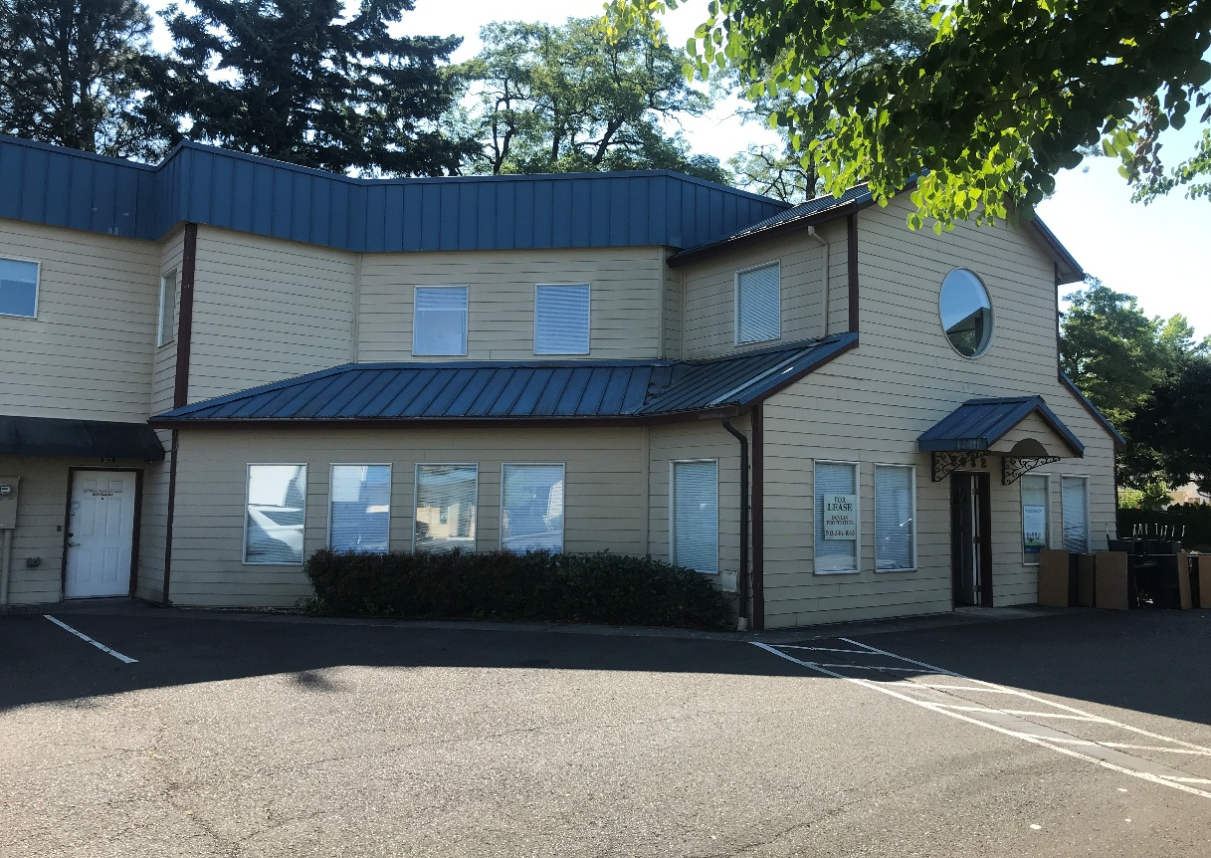

**Excellent Value on Mid-County Office Site**

2632 SE 162nd Avenue, Portland, OR 97236

* Opportunity to lease multi-use site offering many amenities.
* Home to Centennial School District for past 10 years. Available Jan., 2026.
* First floor- classrooms, private offices, kitchen, dining/meeting area, laundry.
* 2nd floor- classrooms, private offices, skylight, open area to first floor. Approx. 2,400 sf
* Can add adjacent storage area with roll up door. Approx. 300 sf additional rent= $300/month.
* Excellent value at $8,300/month gross ($17.50/sf/yr). Separate meters for all utilities.
* Please do not disturb occupants. Call Mike Devlin to arrange walk thru.

Approx. 5,700 sf available

$8,300/mo. Rent (GROSS)

Excellent parking.

Two story, lift served.

Fenced outdoor area.

Flexible use facility.

Available 1-26 or sooner

Centennial Plaza location

* Retail/production
* Warehouse
* 4 Bay doors 14’ hi.
* Great signs. CG zone
* High exposure site.

**DEVLIN PROPERTIES CONTACT: MIKE DEVLIN**

10425 SW 55TH AVENUE phone: 503-246-4045/ 503-901-5407

PORTLAND, OR 97219 [mdevprop@hotmail.com](mailto:mdevprop@hotmail.com)

Enclosed information provided by sources deemed reliable, however, not guaranteed.

**For Lease**