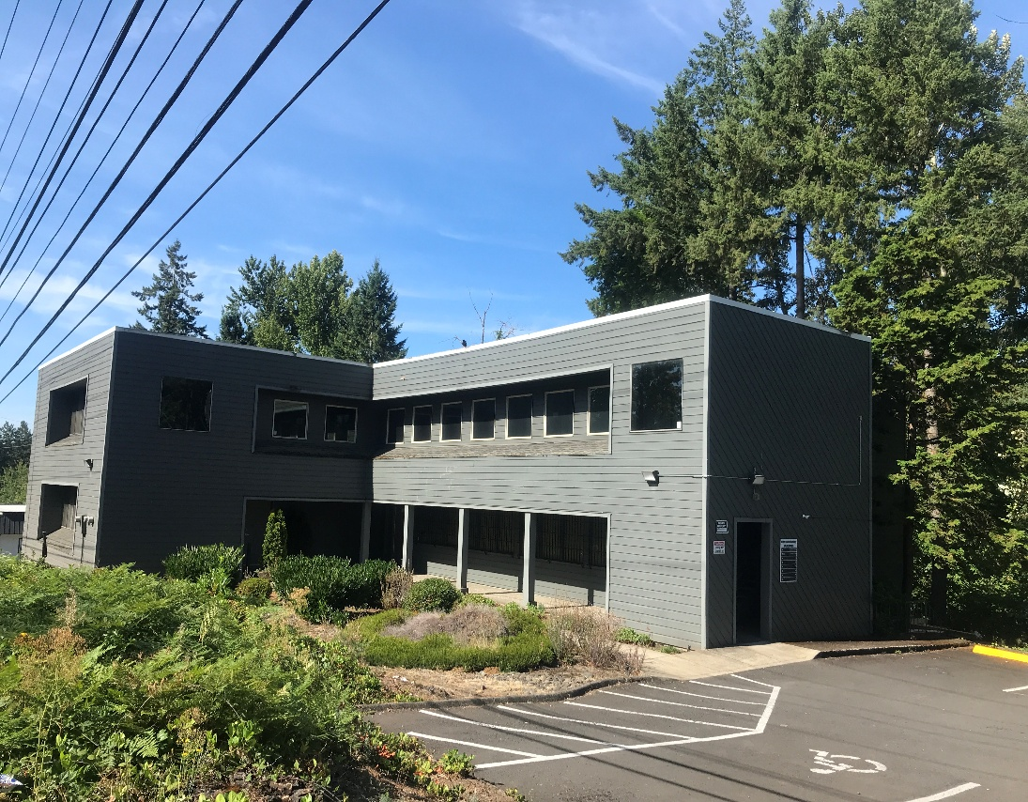

**DEVLIN PROPERTIES CONTACT: MIKE DEVLIN**

10425 SW 55TH AVENUE phone: 503-246-4045/ 503-901-5407

PORTLAND, OR 97219 [mdevprop@hotmail.com](mailto:mdevprop@hotmail.com)

Enclosed information provided by sources deemed reliable, however, not guaranteed.

**Oregon Dairy Office Building**

10505 SW Barbur Blvd., Portland, OR 97215

* Suite 303 available. Approx. 700 sq. accommodates many prof. uses.
* Desirable SW Portland area. Secure premises. Access to N. and S. I-5 nearby.
* Consists of large private office, open work/reception area, small storage area.
* New paint, plank floor covering, HVAC. Pride of ownership throughout. Security alarm.
* Accommodates many prof. uses: law, accounting, consulting, construction.
* Rent: Asking $1,000/month, only about $17/sf/yr. includes all utility costs.
* Vacant. Please call to schedule a walk thru. Mike Devlin 503-901-5407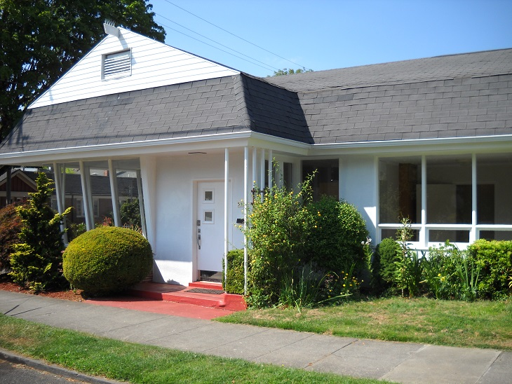
* Just South of SE Foster Road. Over 28K vehicles/day traffic count. 16’ clear to ceiling.

Rent: $1,000/mo.

INCLUDES ALL UTILITIES.

Approx. 700 sf

* Multi-use office.
* Excellent condition.
* Terrific parking
* No CAM charge.
* Great I-5 access.
* Flexible zoning.
* High exposure site.

**For Lease**