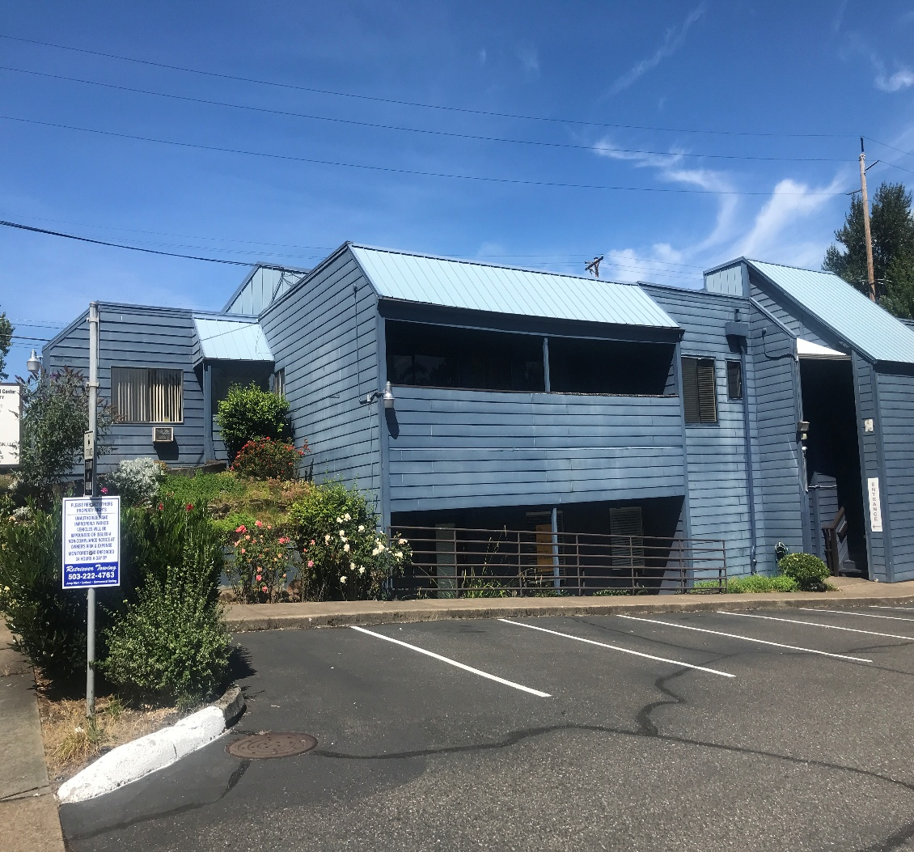

**SW Portland Medical Dental Center**

2350 SW Multnomah Blvd., Portland, OR 97219

* Suite C Available: approx. 1,100 sf on main level 2nd generation med. space.
* Well maintained free-standing building in desirable close-in SW Portland area.
* Consists of some private offices, large reception/adm. area, open bays, restroom.
* Newer paint, floor covering, HEPA filtration, security cameras, medical plumbing.
* Accommodates many medical uses: Naturopathy, Chiropractic, Acupuncture.
* Terrific location with good freeway access to downtown from Mult./Barbur Blvds.
* Rent: Only $1,560/month ($17/sf/yr) plus utilities.
* Vacant. Please call to schedule a walk thru. Mike Devlin 503-901-5407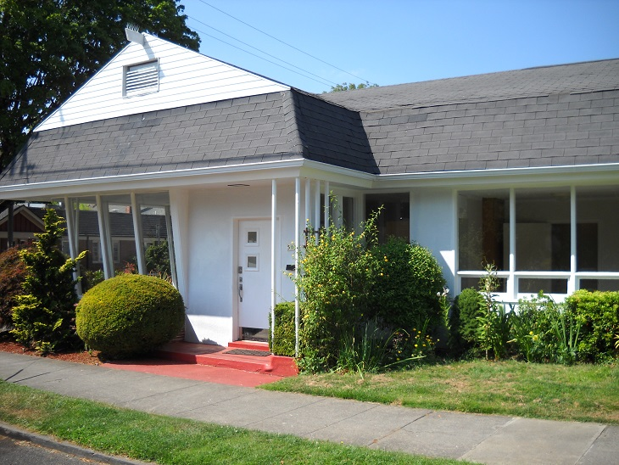
* Just South of SE Foster Road. Over 28K vehicles/day traffic count. 16’ clear to ceiling.

Rent: $1,560/mo.

+ Utilities. (P. tax and Ins. Included)

Approx. 1,100 sf

* Former dental off.
* Excellent condition.
* Excellent parking.
* Great I-5 Access.
* High exposure site.

**DEVLIN PROPERTIES CONTACT: MIKE DEVLIN**

10425 SW 55TH AVENUE phone: 503-246-4045/ 503-901-5407

PORTLAND, OR 97219 [mdevprop@hotmail.com](mailto:mdevprop@hotmail.com)

Enclosed information provided by sources deemed reliable, however, not guaranteed.

**For Lease**