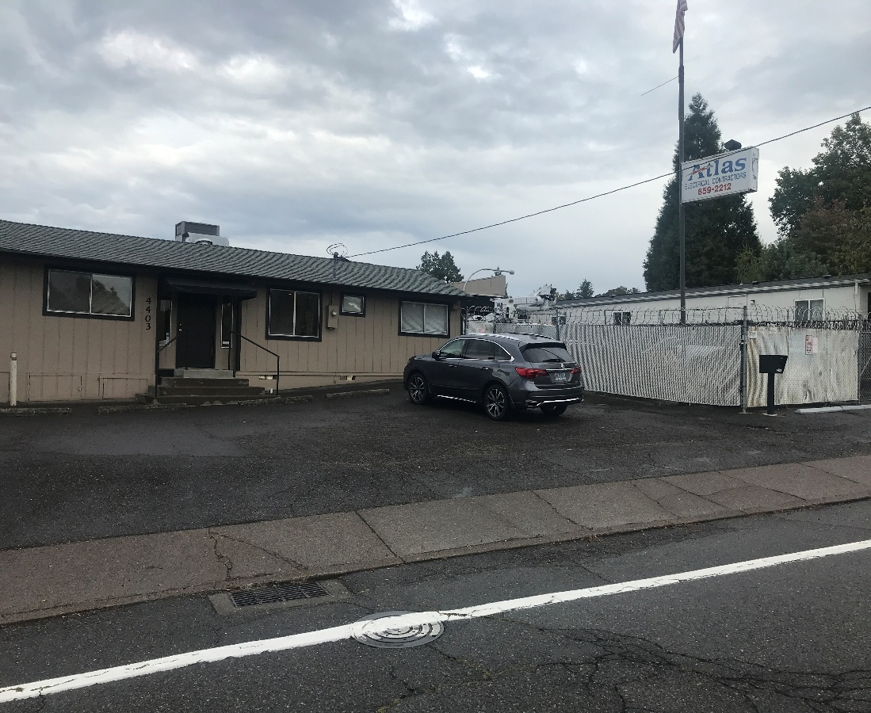

Price: $1,000,000.
Clackamas Co. location
- Approx. 4,000 sf bldg. and yard

- Flexible C3 zone
P. Tax=$5,380.

- Also for Lease
- Terms: $5,000/mo
- Net + tax/ins.
- CO 2 Zoning
Unique Office/Warehouse/yard Site
4403 SE Roethe Road, Milwaukie, OR
- Terrific opportunity for owner/user to purchase or lease Atlas Elec. Site.
- Located just off McLoughlin Blvd. at signalized intersection. About 2 mi. to I-205.
- Atlas Electric occupant obligated thru 7-31-26. Moving to new premises at that time.
- Approx. 4,000 sf bldg. about half office/half warehouse. Approx. 10,700 sf lot.
- Hard to find product with good parking/sign/ fenced,gated, secure asphalt yard.
- Accommodates many contractor, engineer uses. Clean Level 1 and 2 Env. Reports.
- Please do not disturb occupants. Call office to arrange tour/inspection.

DEVLIN PROPERTIES CONTACT: MIKE DEVLIN
10425 SW 55TH AVENUE phone: 503-246-4045/ 503-901-5407
PORTLAND, OR 97219 mdevprop@hotmail.com
Enclosed information provided by sources deemed reliable, however, not guaranteed.

For Sale

F
f

